What is Computer Security?
Computer security is the protection that is set up for computer systems and keeps critical information from unauthorized access, theft, or misuse. There are various practices in place that are widely in use, mainly for the protection of computer systems and networks and preventing potential malicious activities.
While computer hardware is secured in the same way that sensitive equipment such as lockers and doors are protected, critical information and system access and authorization, on the other hand, are protected through complex security tactics and practices.
That’s all for computer security definition. Let’s move on to the section on security threats and issues.
Get 100% Hike!
Master Most in Demand Skills Now !

By providing your contact details, you agree to our Terms of Use & Privacy Policy

Computer Security Threats, Issues, and Vulnerabilities
Computer security threats are potential risks that have the capability of disrupting the normal functioning of computer systems. Cyber threats are on the rise each day, especially with the digitization of the world. Let’s take a look at all kinds of major computer security threats, issues, and vulnerabilities.

Viruses
A Computer Virus is a malicious program that is installed into a computer without the knowledge of its user. This program can replicate itself and infect all the programs and files that are in the system. These viruses make the victim’s computer malfunction or, at the worst, completely unusable.

Computer Worm
A computer worm is a software program that can undergo replication from one computer system to another without the need for human interaction. Computer worms use up all of the hard disk space owing to their replication capability and the speed of replication, which can wreak havoc on the system’s resources. They can even modify or delete files and introduce other malicious programs into the system. Computer worms are also capable of stealing information and introducing a backdoor for hackers to gain unauthorized access and control to the system.
Learn how to save PCs from hackers. Enroll in Cyber Security Certification in Bangalore now.


Phishing
Phishing is a form of cybercrimes, which involves someone posing as a legitimate institution over the telephone, email, or text message in an attempt to trick potential targets to give away personal and critical information like banking details and passwords. This results in financial loss and identity thefts. Even though most people are wary of such attacks, it is completely easy to fall victim to phishing, unfortunately.

Botnet
A botnet is a network of connected computers that have been compromised by hackers without the knowledge of the users. Each of the infected computers in the network is called a ‘zombie computer.’ The infected computer, which now is the bot, is used for carrying out malicious activities in larger-scale attacks like DDoS.

Rootkit
A rootkit is malicious software designed to provide unauthorized access to a computer or restricted areas while actively masking its existence. Through rootkits, hackers can change system configurations and execute files remotely on the host computer.

Keylogger
A keylogger is a type of monitoring software that can track and record all keyboard strokes and activities by a user without his/her knowledge. Also known as the keystroke logger, it is one of the common ways to steal a person’s login credentials.
Check out the Ethical Hacking Course offered by Intellipaat to become a Certified Ethical Hacker.

Importance of Computer Security
If a computer security system is not put in place until a problem arises, it could lead to major issues and concerns, and it will be too late to resolve them. Especially in a data-driven world, it is imperative to keep all kinds of information from malicious hackers and prevent vital information from falling into the wrong hands for misuse.

Career Transition

Computer security helps keep valuable information protected and maintain the health of a computer with no disruptive behavior in its performance caused by viruses and malware.
That’s all for the importance and need of computer security. Read on to learn about different categories of computer security.
Also, check out the blog on Cyber Security VS Information Security!

Types of Computer Security
Here are a few types of computer security tactics that are used widely for the protection of software, hardware, electronic data, and network in computer systems.

Application Security
Application security is the introduction of security features in applications during their development process. This actively helps prevent potential cyber threats such as data breaches, denial-of-service attacks (DoS), SQL injection, and many others. Some examples of application security tools are antivirus software, firewalls, web application firewalls, encryption, etc.

Information Security
Information security is a set of practices that aim to protect the confidentiality, integrity, and availability (known as the CIA triad) of data from unauthorized access and misuse.

Network Security
Network security is any activity that aims to protect the integrity and usability of a network and data. It consists of both hardware and software technologies that are specifically designed to prevent unauthorized intrusion into computer systems and networks.
Learn Cyber Security from the seasoned experts at Intellipaat and pave a successful career.

Endpoint Security
End-users are increasingly becoming the biggest security risk unintentionally. With no-fault from their end, exempting the lack of awareness, the virtual gates of an organization are open to hackers and attacks. Most of the end-users are unaware of the ICT policy, and therefore, it is imperative that the users who handle sensitive information on a regular basis understand and be knowledgeable about all comprehensive security policies, protocols, and procedures.

Internet Security
Internet security is one of the most important types of computer security that come with a set of rules and protocols that focus on specific threats and activities that happen online. It provides protection against hacking, DoS attacks, computer viruses, and malware.
Why we use Information Security?
We use information security to protect valuable information assets from a wide range of threats, including theft, espionage, and cybercrime. Information security is necessary to ensure the confidentiality, integrity, and availability of information, whether it is stored digitally or in other forms such as paper documents. Here are some key reasons why information security is important:
- Protecting sensitive information: Information security helps protect sensitive information from being accessed, disclosed, or modified by unauthorized individuals. This includes personal information, financial data, and trade secrets, as well as confidential government and military information.
- Mitigating risk: By implementing information security measures, organizations can mitigate the risks associated with cyber threats and other security incidents. This includes minimizing the risk of data breaches, denial-of-service attacks, and other malicious activities.
- Compliance with regulations: Many industries and jurisdictions have specific regulations governing the protection of sensitive information. Information security measures help ensure compliance with these regulations, reducing the risk of fines and legal liability.
- Protecting reputation: Security breaches can damage an organization’s reputation and lead to lost business. Effective information security can help protect an organization’s reputation by minimizing the risk of security incidents.
- Ensuring business continuity: Information security helps ensure that critical business functions can continue even in the event of a security incident. This includes maintaining access to key systems and data, and minimizing the impact of any disruptions.
Information Security programs are build around 3 objectives, commonly known as CIA – Confidentiality, Integrity, Availability.
- Confidentiality – means information is not disclosed to unauthorized individuals, entities and process. For example if we say I have a password for my Gmail account but someone saw while I was doing a login into Gmail account. In that case my password has been compromised and Confidentiality has been breached.
- Integrity – means maintaining accuracy and completeness of data. This means data cannot be edited in an unauthorized way. For example if an employee leaves an organisation then in that case data for that employee in all departments like accounts, should be updated to reflect status to JOB LEFT so that data is complete and accurate and in addition to this only authorized person should be allowed to edit employee data.
- Availability – means information must be available when needed. For example if one needs to access information of a particular employee to check whether employee has outstanded the number of leaves, in that case it requires collaboration from different organizational teams like network operations, development operations, incident response and policy/change management.
Denial of service attack is one of the factor that can hamper the availability of information.
Apart from this there is one more principle that governs information security programs. This is Non repudiation.
- Non repudiation – means one party cannot deny receiving a message or a transaction nor can the other party deny sending a message or a transaction. For example in cryptography it is sufficient to show that message matches the digital signature signed with sender’s private key and that sender could have a sent a message and nobody else could have altered it in transit. Data Integrity and Authenticity are pre-requisites for Non repudiation.
- Authenticity – means verifying that users are who they say they are and that each input arriving at destination is from a trusted source.This principle if followed guarantees the valid and genuine message received from a trusted source through a valid transmission. For example if take above example sender sends the message along with digital signature which was generated using the hash value of message and private key. Now at the receiver side this digital signature is decrypted using the public key generating a hash value and message is again hashed to generate the hash value. If the 2 value matches then it is known as valid transmission with the authentic or we say genuine message received at the recipient side
- Accountability – means that it should be possible to trace actions of an entity uniquely to that entity. For example as we discussed in Integrity section Not every employee should be allowed to do changes in other employees data. For this there is a separate department in an organization that is responsible for making such changes and when they receive request for a change then that letter must be signed by higher authority for example Director of college and person that is allotted that change will be able to do change after verifying his bio metrics, thus timestamp with the user(doing changes) details get recorded. Thus we can say if a change goes like this then it will be possible to trace the actions uniquely to an entity.

advantages to implementing an information classification system in an organization’s information security program:
- Improved security: By identifying and classifying sensitive information, organizations can better protect their most critical assets from unauthorized access or disclosure.
- Compliance: Many regulatory and industry standards, such as HIPAA and PCI-DSS, require organizations to implement information classification and data protection measures.
- Improved efficiency: By clearly identifying and labeling information, employees can quickly and easily determine the appropriate handling and access requirements for different types of data.
- Better risk management: By understanding the potential impact of a data breach or unauthorized disclosure, organizations can prioritize resources and develop more effective incident response plans.
- Cost savings: By implementing appropriate security controls for different types of information, organizations can avoid unnecessary spending on security measures that may not be needed for less sensitive data.
- Improved incident response: By having a clear understanding of the criticality of specific data, organizations can respond to security incidents in a more effective and efficient manner.

The Threat, Vulnerability, and Risk these terms are interrelated but not the same. In this article, we are going to discuss the difference between them and how they are related to each other.

Threat
A cyber threat is a malicious act that seeks to steal or damage data or discompose the digital network or system. Threats can also be defined as the possibility of a successful cyber attack to get access to the sensitive data of a system unethically. Examples of threats include computer viruses, Denial of Service (DoS) attacks, data breaches, and even sometimes dishonest employees.

Types of Threat
Threats could be of three types, which are as follows:
- Intentional- Malware, phishing, and accessing someone’s account illegally, etc. are examples of intentional threats.
- Unintentional- Unintentional threats are considered human errors, for example, forgetting to update the firewall or the anti-virus could make the system more vulnerable.
- Natural- Natural disasters can also damage the data, they are known as natural threats.

Vulnerability:
In cybersecurity, a vulnerability is a flaw in a system’s design, security procedures, internal controls, etc., that can be exploited by cybercriminals. In some very rare cases, cyber vulnerabilities are created as a result of cyberattacks, not because of network misconfigurations. Even it can be caused if any employee anyhow downloads a virus or a social engineering attack.

Types of Vulnerability
Vulnerabilities could be of many types, based on different criteria, some of them are:
- Network- Network vulnerability is caused when there are some flaws in the network’s hardware or software.
- Operating system- When an operating system designer designs an operating system with a policy that grants every program/user to have full access to the computer, it allows viruses and malware to make changes on behalf of the administrator.
- Human- Users’ negligence can cause vulnerabilities in the system.
- Process- Specific process control can also cause vulnerabilities in the system.

Risk:
Cyber risk is a potential consequence of the loss or damage of assets or data caused by a cyber threat. Risk can never be completely removed, but it can be managed to a level that satisfies an organization’s tolerance for risk. So, our target is not to have a risk-free system, but to keep the risk as low as possible.
Cyber risks can be defined with this simple formula- Risk = Threat + Vulnerability. Cyber risks are generally determined by examining the threat actor and type of vulnerabilities that the system has.

Types of Risks
There are two types of cyber risks, which are as follows:
1. External- External cyber risks are those which come from outside an organization, such as cyberattacks, phishing, ransomware, DDoS attacks, etc.
2. Internal- Internal cyber risks come from insiders. These insiders could have malicious intent or are just not be properly trained.

Difference Between Threat, Vulnerability, and Risk
 | Threat | Vulnerability | Risks
1. | Take advantage of vulnerabilities in the system and have the potential to steal and damage data. | Known as the weakness in hardware, software, or designs, which might allow cyber threats to happen. | The potential for loss or destruction of data is caused by cyber threats.
2. | Generally, can’t be controlled. | Can be controlled. | Can be controlled.
3. | It may or may not be intentional. | Generally, unintentional. | Always intentional.
4. | Can be blocked by managing the vulnerabilities. | Vulnerability management is a process of identifying the problems, then categorizing them, prioritizing them, and resolving the vulnerabilities in that order. | Reducing data transfers, downloading files from reliable sources, updating the software regularly, hiring a professional cybersecurity team to monitor data, developing an incident management plan, etc. help to lower down the possibility of cyber risks.
5. | Can be detected by anti-virus software and threat detection logs. | Can be detected by penetration testing hardware and many vulnerability scanners. | Can be detected by identifying mysterious emails, suspicious pop-ups, observing unusual password activities, a slower than normal network, etc.
Last Updated : 16 Dec, 2021
12
Similar Reads


Difference between Threat and Attack


Difference Between Vulnerability and Exploit


Basic Network Attacks in Computer Network

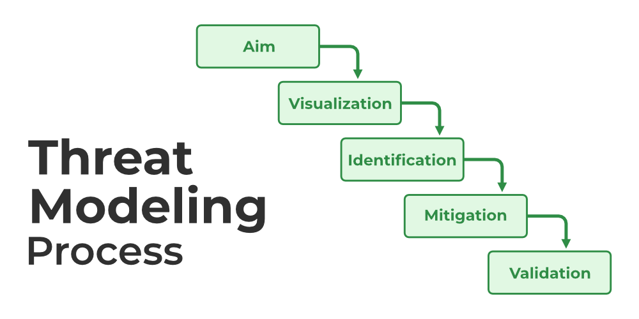
Threat Modelling


DFD Based Threat modelling | Set 1


DFD Based Threat Modelling | Set 2


Advanced Persistent Threat


What is Unified Threat Management (UTM)?


Different Types of Threat to E-Commerce


Difference between Storage Area Network (SAN) and Network Attached Storage (NAS)

Types of Viruses

A
aastha98

• Read
• Discuss
• Courses

A virus is a fragment of code embedded in a legitimate program. Viruses are self-replicating and are designed to infect other programs. They can wreak havoc in a system by modifying or destroying files causing system crashes and program malfunctions. On reaching the target machine a virus dropper(usually a trojan horse) inserts the virus into the system.
For more details, refer to this.

Various types of viruses:
- File Virus:
This type of virus infects the system by appending itself to the end of a file. It changes the start of a program so that the control jumps to its code. After the execution of its code, the control returns back to the main program. Its execution is not even noticed. It is also called a Parasitic virus because it leaves no file intact but also leaves the host functional.
- Boot sector Virus:
It infects the boot sector of the system, executing every time system is booted and before the operating system is loaded. It infects other bootable media like floppy disks. These are also known as memory viruses as they do not infect the file systems.
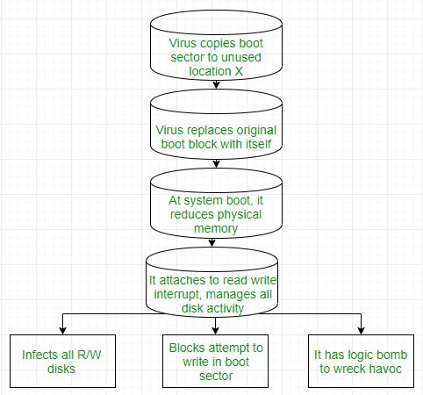
- Macro Virus:
Unlike most viruses which are written in a low-level language(like C or assembly language), these are written in a high-level language like Visual Basic. These viruses are triggered when a program capable of executing a macro is run. For example, the macro viruses can be contained in spreadsheet files.
- Source code Virus:
It looks for source code and modifies it to include virus and to help spread it.
- Polymorphic Virus:
A virus signature is a pattern that can identify a virus(a series of bytes that make up virus code). So in order to avoid detection by antivirus a polymorphic virus changes each time it is installed. The functionality of the virus remains the same but its signature is changed.
- Encrypted Virus:
In order to avoid detection by antivirus, this type of virus exists in encrypted form. It carries a decryption algorithm along with it. So the virus first decrypts and then executes.
- Stealth Virus:
It is a very tricky virus as it changes the code that can be used to detect it. Hence, the detection of viruses becomes very difficult. For example, it can change the read system call such that whenever the user asks to read a code modified by a virus, the original form of code is shown rather than infected code.
- Tunneling Virus:
This virus attempts to bypass detection by antivirus scanner by installing itself in the interrupt handler chain. Interception programs, which remain in the background of an operating system and catch viruses, become disabled during the course of a tunneling virus. Similar viruses install themselves in device drivers.
- Multipartite Virus:
This type of virus is able to infect multiple parts of a system including the boot sector, memory, and files. This makes it difficult to detect and contain.
- Armored Virus:
An armored virus is coded to make it difficult for antivirus to unravel and understand. It uses a variety of techniques to do so like fooling antivirus to believe that it lies somewhere else than its real location or using compression to complicate its code.
- Browser Hijacker:
As the name suggests this virus is coded to target the user’s browser and can alter the browser settings. It is also called the browser redirect virus because it redirects your browser to other malicious sites that can harm your computer system.
- Memory Resident Virus:
Resident viruses installation store for your RAM and meddle together along with your device operations. They behave in a very secret and dishonest way that they can even connect themselves for the anti-virus software program files.
- Direct Action Virus:
The main perspective of this virus is to replicate and take action when it is executed. When a particular condition is met the virus will get into action and infect files in the directory that are specified in the AUTOEXEC.BAT file path.
- Overwrite virus:
This type of virus deletes the information contained in the file that it infects, rendering them partially or totally is useless once they have been infected.
- Directory Virus:
This virus is also called called File System Virus or Cluster Virus. It infects the directory of the computer by modifying the path that is indicating the location of a file.
- Companion Virus:
This kind of virus usually use the similar file name and create a different extension of it. For example, if there’s a file “Hello.exe”, the virus will create another file named “Hello.com” and will hide in the new file
- FAT Virus:
The File Allocation Table is the part of the disk used to store all information about the location of files, available space , unusable space etc.
This virus affects the FAT section and may damage crucial information.
Virus:
Virus is a computer program or software that connect itself to another software or computer program to harm computer system. When the computer program runs attached with virus it perform some action such as deleting a file from the computer system. Virus can’t be controlled by remote.
Worms:
Worms is also a computer program like virus but it does not modify the program. It replicate itself more and more to cause slow down the computer system. Worms can be controlled by remote.
Trojan Horse:
Trojan Horse does not replicate itself like virus and worms. It is a hidden piece of code which steal the important information of user. For example, Trojan horse software observe the e-mail ID and password while entering in web browser for logging.

Difference between Virus, Worm and Trojan Horse:
Virus | Worm | Trojan Horse
Virus is a software or computer program that connect itself to another software or computer program to harm computer system. | Worms replicate itself to cause slow down the computer system. | Trojan Horse rather than replicate capture some important information about a computer system or a computer network.
Virus replicates itself. | Worms are also replicates itself. | But Trojan horse does not replicate itself.
Virus can’t be controlled by remote. | Worms can be controlled by remote. | Like worms, Trojan horse can also be controlled by remote.
Spreading rate of viruses are moderate. | While spreading rate of worms are faster than virus and Trojan horse. | And spreading rate of Trojan horse is slow in comparison of both virus and worms.
The main objective of virus to modify the information. | The main objective of worms to eat the system resources. | The main objective of Trojan horse to steal the information.
Viruses are executed via executable files. | Worms are executed via weaknesses in system. | Trojan horse executes through a program and interprets as utility software.

Difference between Active attack and Passive attack
This article is going to be very interesting and important for readers that are interested in cyber security. In this article, we are going to discuss two major types of security attacks that are Active attack and Passive attack.
Hope this article will be informative to you, and give you the sufficient information about Active attack, Passive attack, and their comparison. So, without any delay, let's start our topic.

What is a Security attack?
Security attacks jeopardize the system's security. These are the unauthorized or illegal actions that are taken against the government, corporate, or private IT assets in order to destroy, modify, or steal the sensitive data. They are further classified into active and passive attacks, in which the attacker gets unlawful access to the system's resources.

Active attacks
In active attacks, the attacker intercepts the connection and efforts to modify the message's content. It is dangerous for integrity and availability of the message. Active attacks involve Masquerade, Modification of message, Repudiation, Replay, and Denial of service. The system resources can be changed due to active attacks. So, the damage done with active attacks can be harmful to the system and its resources.
In the below image, we can see the process of active attacks.
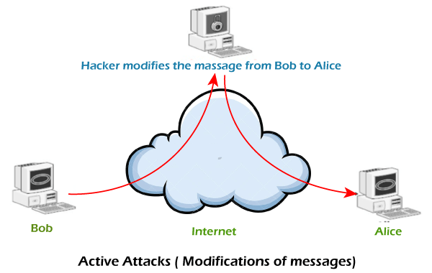
In active attacks, the victim gets notified about the attack. The implication of an active attack is typically difficult and requires more effort. Active attacks can be prevented by using some techniques. We can try the below-listed measures to prevent these attacks -
- Use of one-time password help in the authentication of the transactions between two parties.
- There could be a generation of the random session key that will be valid for a single transaction. It should prevent the malicious user from retransmitting the actual information once the session ends.

Passive attacks
In passive attacks, the attacker observes the messages, then copy and save them and can use it for malicious purposes. The attacker does not try to change the information or content he/she gathered. Although passive attacks do not harm the system, they can be a danger for the confidentiality of the message.
In the below image, we can see the process of passive attacks.
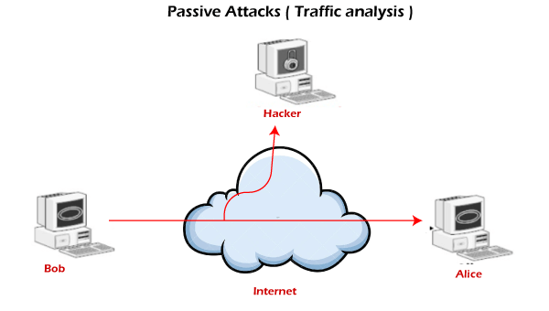
Unlike active attacks, in passive attacks, victims do not get informed about the attack. It is difficult to detect as there is no alteration in the message. Passive attacks can be prevented by using some encryption techniques. We can try the below-listed measures to prevent these attacks -
- We should avoid posting sensitive information or personal information online. Attackers can use this information to hack your network.
- We should use the encryption method for the messages and make the messages unreadable for any unintended intruder.

Active attack v/s Passive attack
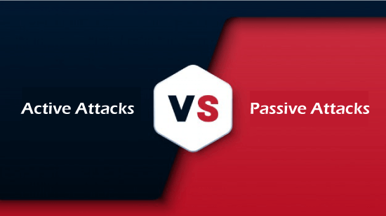
Now, let's see the comparison chart between Active attack and Passive attack. We are comparing both security attacks on the basis of some characteristics.
On the basis of | Active attack | Passive attack
Definition | In active attacks, the attacker intercepts the connection and efforts to modify the message's content. | In passive attacks, the attacker observes the messages, then copy and save them and can use it for malicious purposes.
Modification | In an active attack, the attacker modifies the actual information. | In passive attacks, information remains unchanged.
Victim | In active attacks, the victim gets notified about the attack. | Unlike active attacks, in passive attacks, victims do not get informed about the attack.
System's impact | The damage done with active attacks can be harmful to the system and its resources. | The passive attacks do not harm the system.
System resources | In active attacks, the system resources can be changed. | In passive attacks, the system resources remain unchanged.
Dangerous for | They are dangerous for the integrity and availability of the message. | They can be dangerous for confidentiality of the message.
Emphasis on | In active attacks, attention is on detection. | In active attacks, attention is on prevention.
Types | Active attacks involve Masquerade, Modification of message, Repudiation, Replay, and Denial of service. | It involves traffic analysis, the release of a message.
Prevention | Active attacks are tough to restrict from entering systems or networks. | Unlike active attacks, passive attacks are easy to prohibit.

- DDOS,
- backdoors and trapdoors
- , sniffing,
- spoofing,
- man in the middle,
- replay,
- TCP/IP Hacking
- , encryption attacks
- LEARN FROM INTERNET

Operating System Hardening
In this article, you will learn about the operating system hardening with its tips.

What is operating system hardening?
It is a type of system hardening. It involves patching and applying advanced system security procedures to secure the server's OS. Automatically installing updates, patches, and service packs are some of the most effective methods to harden the OS.
An OS hardening is similar to application hardening in that the OS is a type of software. Operating system hardening provides basic software that grants those applications access to specific activities on your server.
Operating system developers frequently perform a good job of issuing OS updates and encouraging users to install them on Microsoft, Linux, and iOS. These frequent updates can help to keep your system secure and resilient to cyber-attacks.
Backward Skip 10sPlay VideoForward Skip 10s
Hardening an operating system usually includes:
- Following security practices and making sure your configuration is secure.
- Additional security measures are implemented, including endpoint protection systems, firewalls, and OS security extensions like AppArmor for Linux.
- Patches and service packs are automatically applied to the operating system.
- It removes the unnecessary drivers.
- It limits and authenticates system access permissions.
- It encrypts the SSD or HDD that stores and hosts the OS.

Operating System Hardening Tips
There are various operating system hardening tips. Some tips for the operating system hardening are as follows:

1. Pitch Management
It includes planning, testing, timely installation, and ongoing auditing to guarantee that client computer' operating systems and particular programs are always patched with the most recent versions.

2. Service Packs
Service packs keep updated applications and install the most recent version. There is no single activity that can protect against all types of attacks, including zero-day assaults; however, applying service packs minimizes these risks.

3. Endpoint Protection
Windows Defender is a powerful endpoint protection solution included with the OS. Endpoint protection platforms (EPP) provide numerous levels of protection for OS, including email and social engineering protection, malware prevention, detection of malicious processes, and automated OS isolation in the case of an infection.

4. Access Control
Use features to limit access to networks, files, and some other resources. Its management features for individuals and groups are available in all major OS, such as Linux, Windows, and OS X. As the default settings are typically less stringent than required, you must configure access to use the principle of least privilege.

5. Security Templates
Use templates to handle and enforce security configurations in a good manner. Templates may be used to keep track of group policies and guarantee consistency.

6. Establish Group policies
Sometimes, user error may lead to a successful cyber attack. One method to avoid this is to define the groups to whom access is granted clearly and to stick to those guidelines. Update user policies and ensure that everyone is aware of and attaches to them. Enforce wise behaviors like using strong passwords.

7. Clean Programs
Any apps which are no longer in use should be removed. This method may assist you in identifying and repairing security flaws and reducing risk. Any app installed on the system should be checked on a regular basis because it could be a gateway for malicious attackers. It should not be permitted to use software that the company has not approved or reviewed.

8. Data and workload isolation
Data and workload isolation ensure that critical databases and applications run on separate virtual machines, isolating them from unrelated workloads and lowering the attack surface. You may also isolate programs by limiting network access between distinct workloads. As a result, if an attacker gains control of one workload, they may not gain access to another.

